

Semester One Examination, 2021

Question/Answer booklet

MATHEMATICS  
SPECIALIST  
UNIT 3

**SOLUTIONS**

Section One:  
Calculator-free

|  |  |  |  |  |  |  |  |  |  |  |
| --- | --- | --- | --- | --- | --- | --- | --- | --- | --- | --- |
| WA student number: In figures |  |  |  |  |  |  |  |  |  |  |

In words

Your name

|  |  |
| --- | --- |
| Number of additional answer booklets used (if applicable): |  |

## Time allowed for this section

Reading time before commencing work: five minutes

Working time: fifty minutes

## Materials required/recommended for this section

***To be provided by the supervisor***

This Question/Answer booklet

Formula sheet

***To be provided by the candidate***

Standard items: pens (blue/black preferred), pencils (including coloured), sharpener,  
correction fluid/tape, eraser, ruler, highlighters

Special items: nil

## Important note to candidates

No other items may be taken into the examination room. It is **your** responsibility to ensure that you do not have any unauthorised material. If you have any unauthorised material with you, hand it to the supervisor **before** reading any further.

## Structure of this paper

|  |  |  |  |  |  |
| --- | --- | --- | --- | --- | --- |
| Section | Number of questions available | Number of questions to be answered | Working time (minutes) | Marks available | Percentage of examination |
| Section One: Calculator-free | 8 | 8 | 50 | 50 | 35 |
| Section Two: Calculator-assumed | 13 | 13 | 100 | 90 | 65 |
|  | | |  | **Total** | 100 |

## Instructions to candidates

1. The rules for the conduct of examinations are detailed in the school handbook. Sitting this examination implies that you agree to abide by these rules.

2. Write your answers in this Question/Answer booklet preferably using a blue/black pen.  
Do not use erasable or gel pens.

3. You must be careful to confine your answers to the specific question asked and to follow any instructions that are specific to a particular question.

4. Show all your working clearly. Your working should be in sufficient detail to allow your answers to be checked readily and for marks to be awarded for reasoning. Incorrect answers given without supporting reasoning cannot be allocated any marks. For any question or part question worth more than two marks, valid working or justification is required to receive full marks. If you repeat any question, ensure that you cancel the answer you do not wish to have marked.

5. It is recommended that you do not use pencil, except in diagrams.

6. Supplementary pages for planning/continuing your answers to questions are provided at the end of this Question/Answer booklet. If you use these pages to continue an answer, indicate at the original answer where the answer is continued, i.e. give the page number.

7. The Formula sheet is not to be handed in with your Question/Answer booklet.

Section One: Calculator-free 35% (50 Marks)

This section has**eight** questions. Answer **all** questions. Write your answers in the spaces provided.

Working time: 50 minutes.

Question 1 (5 marks)

The displacement vector of a particle at time $t$ seconds is given by $r\left(t\right)=\left(\begin{matrix}\sin{(2t)} \\ 3t \\ \cos{(2t)}\end{matrix}\right)$ cm.

Show that the particle is moving at a constant speed and determine this speed.

|  |
| --- |
| **Solution** |
| Velocity is derivative of displacement: $$v\left(t\right)=\frac{d}{dt}\left(r\left(t\right)\right)=\left(\begin{matrix}2\cos{(2t)} \\ 3 \\ -2sin(2t)\end{matrix}\right)$$ Speed is magnitude of velocity:  Hence speed of particle is a constant $\sqrt{13}$ cm/s. |
| **Specific behaviours** |
| ✓ indicates derivative of displacement vector  ü correct derivative of all components  ü forms expression for speed  ü eliminates trigonometric terms  ü states speed |

Question 2 (6 marks)

Let $p\left(z\right)=z^{4}-2z^{3}+14z^{2}-18z+45$.

(a) Show that $z-3i$ is a factor of $p(z)$. (2 marks)

|  |
| --- |
| **Solution** |
| $$p\left(3i\right)={\left(3i\right)}^{4}-2{\left(3i\right)}^{3}+14{\left(3i\right)}^{2}-18\left(3i\right)+45 \\ =81+54i-126-54i+45 \\ =0$$ |
| **Specific behaviours** |
| ✓ shows substitution for $p\left(3i\right)$ ü simplifies to obtain all terms in second line |

(b) Solve the equation $p\left(z\right)=0$. (4 marks)

|  |
| --- |
| **Solution** |
| Complex roots appear in conjugate pairs, so $z=±3i$.  Hence $p\left(z\right)=\left(z-3i\right)\left(z+3i\right)∙q\left(z\right)=\left(z^{2}+9\right)∙q(z)$ By inspection, $p(z)=(z^{2}+9)(z^{2}-2z+5)$. $$z^{2}-2z+5=0 \\ {\left(z-1\right)}^{2}=-4 \\ z=1±2i$$ Hence $p\left(z\right)=0$ when $z=±3i, 1±2i$. |
| **Specific behaviours** |
| ✓ uses conjugate of given factor  ü factors $p(z)$ into quadratics  ü indicates appropriate method to solve second quadratic  ü obtains all four complex solutions |

Question 3 (7 marks)

The functions $f$ and $g$ are defined as $f\left(x\right)=\begin{matrix}x-2 \\ \overline{x+2}\end{matrix}$ and $g\left(x\right)=\left|x\right|$.

(a) Sketch the graph of $y=f(x)$ on the axes below. (3 marks)

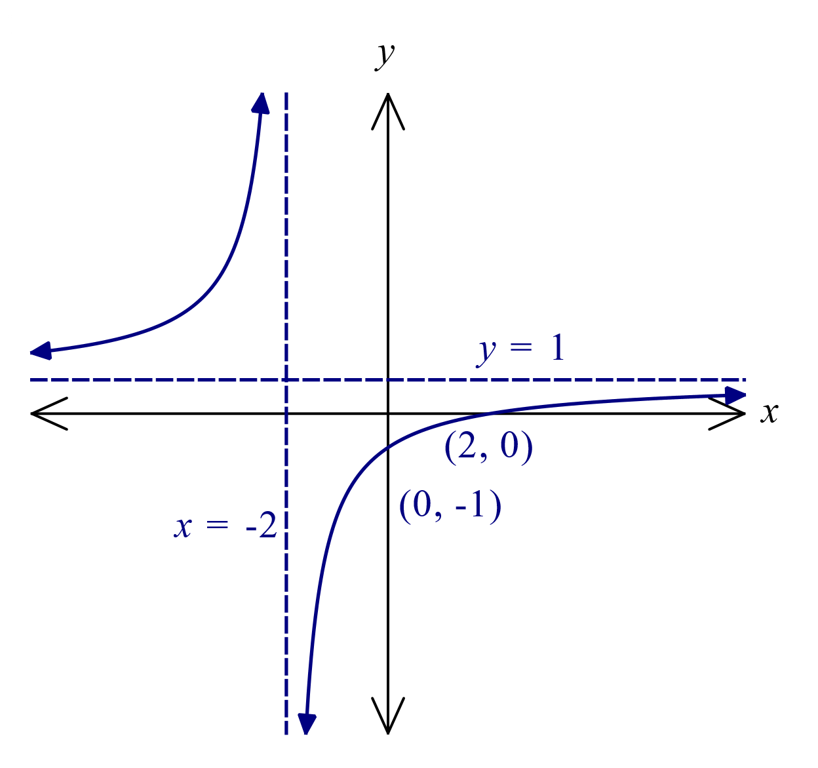

|  |
| --- |
| **Solution** |
| $$f\left(x\right)=1-\frac{4}{x+2}$$ See graph. |
| **Specific behaviours** |
| ü both asymptotes  ü axes intercepts  ü hyperbolic curves |

(b) Sketch the graph of $y=f\left(g(x)\right)$ on the axes below. (3 marks)

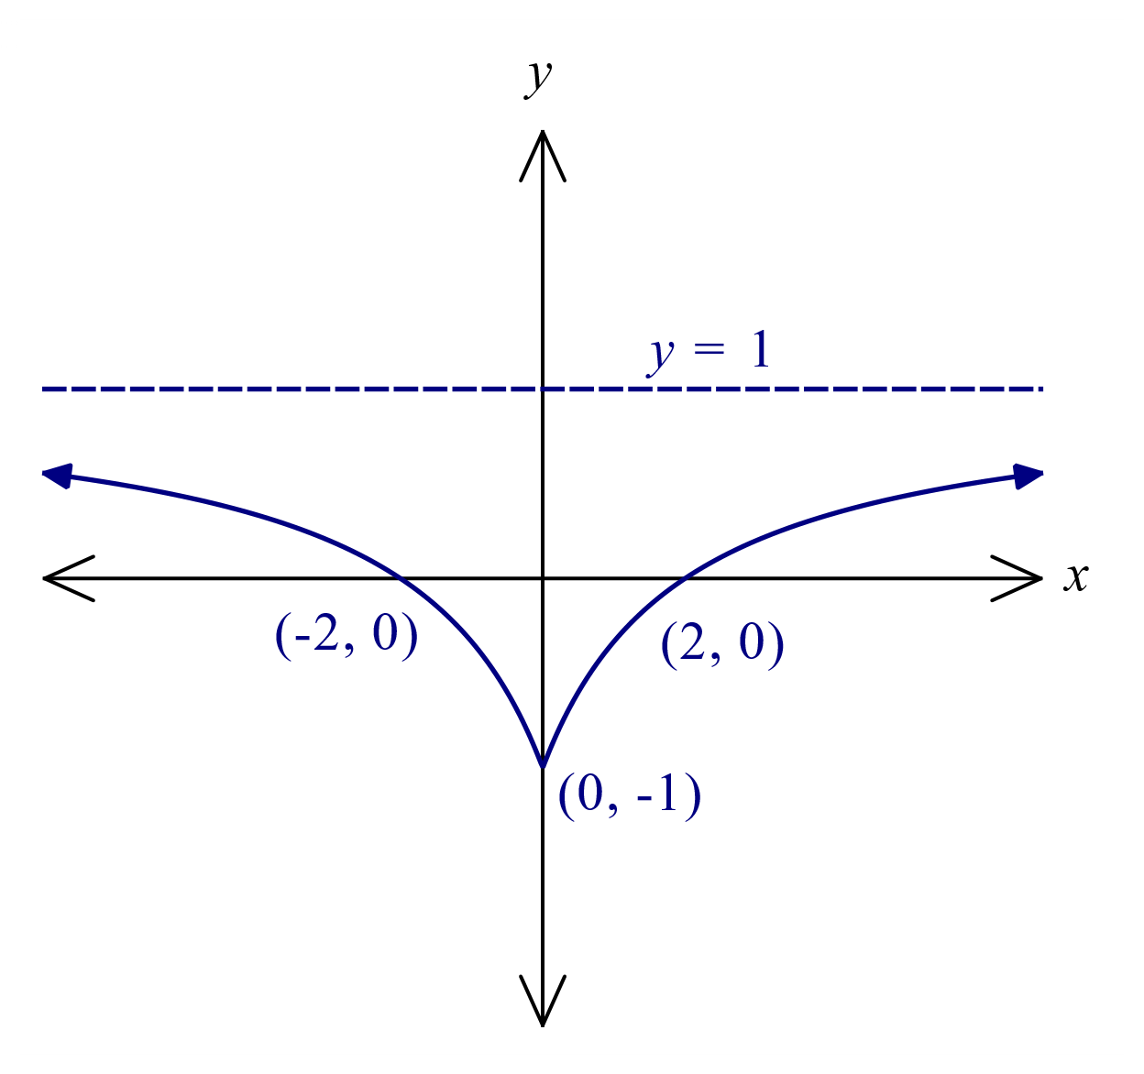

|  |
| --- |
| **Solution** |
| See graph |
| **Specific behaviours** |
| ✓ horizontal asymptote  ü curve from $(0, -1)$ thru' $(2, 0)$ ü uses symmetry to complete |

(c) Determine the range of function $h$, where $h\left(x\right)=\left|f\left(g\left(x\right)\right)\right|$. (1 mark)

|  |
| --- |
| **Solution** |
| Graph of $y=h(x)$ obtained from graph in (b) by reflecting parts of curve below $x$-axis above axis. Hence: $$R_{h}=\{y:y∈R, 0≤y≤1\}$$ |
| **Specific behaviours** |
| ü correct range |

Question 4 (6 marks)

Let $u=\sqrt{3}-i$ and $v=1-i$.

(a) Express $u$ and $v$ in polar form and hence show that $u÷v=\sqrt{2}\operatorname{cis}\left(\begin{matrix}π \\ \overline{12}\end{matrix}\right)$. (3 marks)

|  |
| --- |
| **Solution** |
| $$u=2\operatorname{cis}\left(-\frac{π}{6}\right), v=\sqrt{2}\operatorname{cis}\left(-\frac{π}{4}\right)$$ Hence $$\frac{u}{v}=\frac{2}{\sqrt{2}}\operatorname{cis}\left(-\frac{π}{6}-\left(-\frac{π}{4}\right)\right) \\ =\sqrt{2}\operatorname{cis}\left(\frac{π}{12}\right)$$ |
| **Specific behaviours** |
| ✓ expresses $u$ and $v$ in polar form  ü clearly shows difference of arguments  ü shows quotient of moduli and simplifies |

(b) Hence show that $\sin\left(\begin{matrix}π \\ \overline{12}\end{matrix}\right)=\begin{matrix}\sqrt{6}-\sqrt{2} \\ \overline{ 4 }\end{matrix}$. (3 marks)

|  |
| --- |
| **Solution** |
| $$\sqrt{2}\left(\cos\left(\frac{π}{12}\right)+i\sin\left(\frac{π}{12}\right)\right)=\frac{u}{v}=\frac{\sqrt{3}-i}{1-i}×\frac{1+i}{1+i}$$ Imaginary parts: $$\sqrt{2}\sin\left(\frac{π}{12}\right)=\frac{\sqrt{3}-1}{2} \\ ∴\sin\left(\frac{π}{12}\right)=\frac{1}{\sqrt{2}}\left(\frac{\sqrt{3}-1}{2}\right) \\ =\frac{\sqrt{6}-\sqrt{2}}{4}$$ |
| **Specific behaviours** |
| ✓ forms expression $\frac{u}{v}×\frac{\overline{v}}{\overline{v}}$ ü simplifies imaginary part of expression  ü clearly shows use of result from (a) to obtain required value |

Question 5 (6 marks)

The equations of planes $Π_{1}, Π_{2}$ and $Π_{3}$ are $x-z=1, y+2z=3$ and $x+y+z=4$ respectively.

(a) Explain whether any of these planes are parallel. (2 marks)

|  |
| --- |
| **Solution** |
| The planes have normal vectors $\left(1, 0, -1\right), (0, 1, 2)$ and $(1, 1, 1)$.  Since none of these vectors are scalar multiples of each other then none of the planes are parallel. |
| **Specific behaviours** |
| ✓ indicates the normal vector for each plane  ü explains why none are parallel |

(b) Solve the system of linear equations for the three planes. (3 marks)

|  |
| --- |
| **Solution** |
| $Π_{1}+Π_{2}:$ $$x-z+y+2z=1+3 \\ x+y+z=4$$ Hence $Π_{1}+Π_{2}=Π_{3}$, and so the system is dependent with an infinite number of solutions, given by the parameter $λ∈R$: $$x=λ, z=λ-1, y=3-2\left(λ-1\right)$$ Hence $$x=λ, y=5-2λ, z=λ-1$$ |
| **Specific behaviours** |
| ü uses elimination correctly to realise dependency  ü deduces that there are an infinite number of solutions  ü sets up Gaussian elimination correctly or otherwise |

(c) Describe the geometric interpretation of the solution of the system of equations. (1 mark)

|  |
| --- |
| **Solution** |
| The system represents three non-parallel planes that intersect in a single straight line (a sheaf of planes). |
| **Specific behaviours** |
| ✓ correct interpretation |

Question 6 (7 marks)

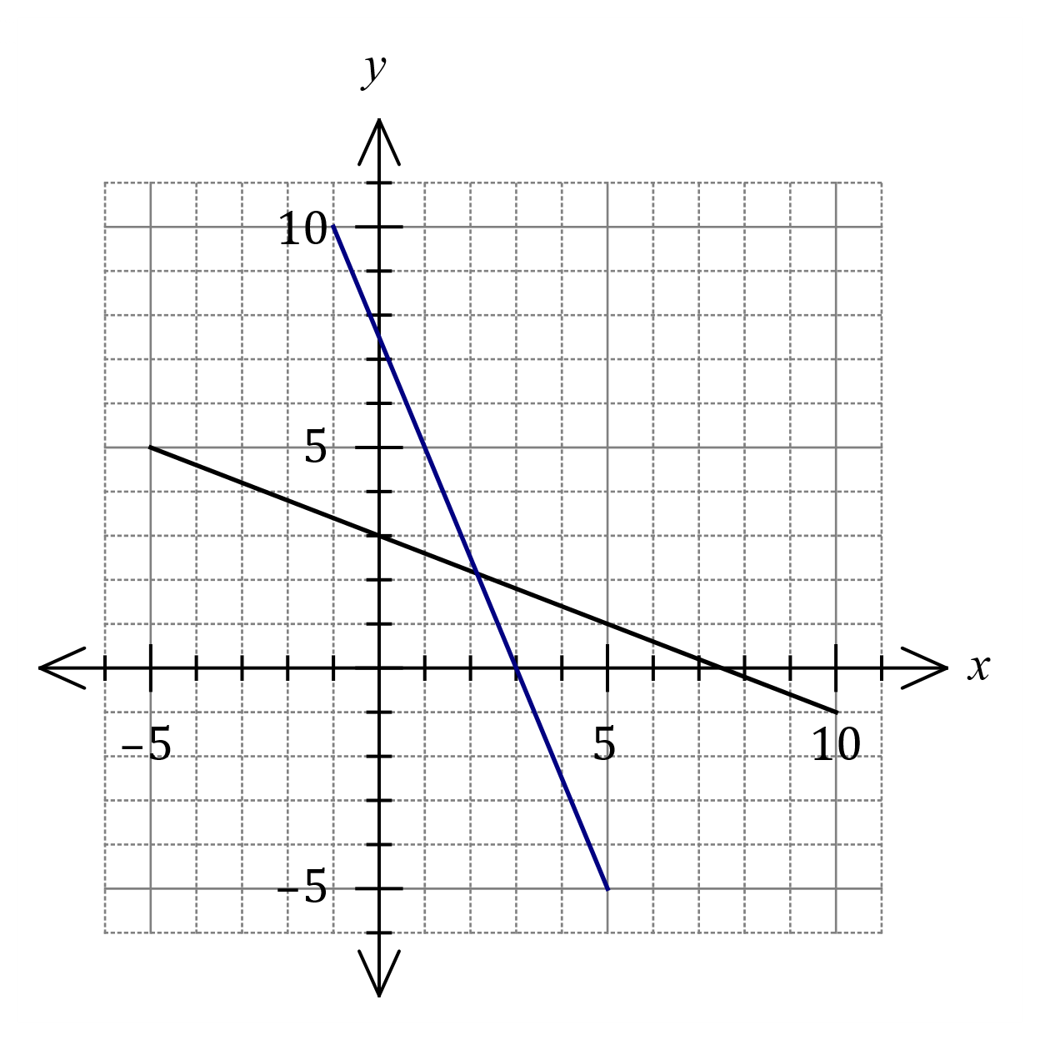Linear function $f$ has domain $-5≤x≤10$  
and is shown on the graph at right.

|  |
| --- |
| **Solution (b)** |
| See graph |
| **Specific behaviours** |
| ✓ endpoints  ü straight line |

(a) Determine $f∘f(7.5)$. (1 mark)

|  |
| --- |
| **Solution** |
| $$f∘f\left(7.5\right)=f\left(0\right)=3$$ |
| **Specific behaviours** |
| ✓ correct value |

(b) Draw the graph of $y=f^{-1}(x)$  
on the same axes. (2 marks)

Function $g$ is defined by $g\left(x\right)=\begin{matrix}4+3x \\ \overline{ 5-x }\end{matrix}, x≠5$.

(c) Determine $g^{-1}(x)$. (2 marks)

|  |
| --- |
| **Solution** |
| $$x=\frac{4+3y}{5-y} \\ 5x-xy-3y-4=0 \\ y\left(x+3\right)=5x-4 \\ y=g^{-1}\left(x\right)=\frac{5x-4}{x+3}, x≠-3$$ |
| **Specific behaviours** |
| ✓ cross multiplies and factors out $y$ ü correct inverse, with domain restriction |

(d) Solve the equation $g∘f\left(x\right)=0.8$. (2 marks)

|  |
| --- |
| **Solution** |
| $$f\left(x\right)=g^{-1}\left(0.8\right)=\frac{0}{3.8}=0$$ $$x=f^{-1}\left(0\right)=7.5$$ |
| **Specific behaviours** |
| ✓ uses inverse of $g$ to obtain  ✓ uses graph of inverse of $f$ to obtain $x$ |

Question 7 (6 marks)

The point $A$ lies on the surface of a sphere with diameter $OB$. The position vectors of $A$ and $B$ relative to $O$ are $a$ and $b$ respectively.

(a) Prove that $a∙b={\left|a\right|}^{2}$. (2 marks)

|  |
| --- |
| **Solution** |
| $∠OAB=90°$ since angle in semi-circle. |
| **Specific behaviours** |
| ü indicates, with reason, that scalar product must be $0$ ü completes proof |

The point $P$ lies on the diameter of the sphere such that $OB$ is perpendicular to $AP$ and $\vec{OP}=λb$.

(b) When $a=i+2j-k$ and $b=2i+j-2k$, determine the value of the constant $λ$ and the position vector of $P$ relative to $O$. (4 marks)

|  |
| --- |
| **Solution** |
| Since $\vec{AP}⊥\vec{OB}$ then $\left(λb-a\right)∙b=0$. $$λ\left(\begin{matrix}2 \\ 1 \\ -2\end{matrix}\right)∙\left(\begin{matrix}2 \\ 1 \\ -2\end{matrix}\right)=\left(\begin{matrix}1 \\ 2 \\ -1\end{matrix}\right)∙\left(\begin{matrix}2 \\ 1 \\ -2\end{matrix}\right) \\ 9λ=6 \\ λ=\frac{2}{3}$$ $$\vec{OP}=\frac{2}{3}b=\frac{2}{3}\left(\begin{matrix}2 \\ 1 \\ -2\end{matrix}\right)=\left(\begin{matrix}4/3 \\ 2/3 \\ -4/3\end{matrix}\right)$$ |
| **Specific behaviours** |
| ✓ forms equation using scalar product  ü correct scalar products  ü value of $λ$ ü correct position vector |

Question 8 (7 marks)

Let $u$ and $v$ be the two square roots of the complex number $3-4i$. On the diagram below, indicate the locus of a complex number $z$ which satisfies $\left|z\right|≤\sqrt{5}$ and $\left|z-u\right|=|z-v|$.

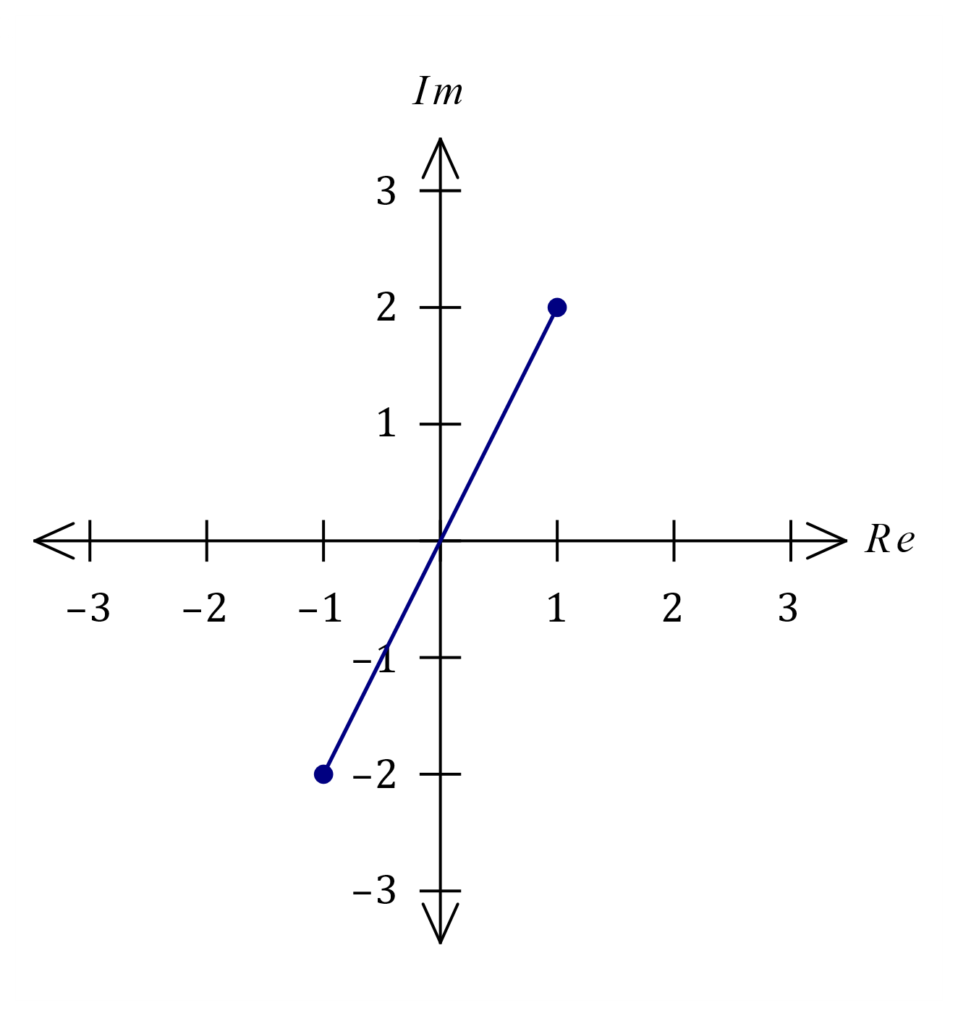

|  |
| --- |
| **Solution** |
| Let $u=a+bi$ so that ${\left(a+bi\right)}^{2}=3-4i$.  From modulus .  But .  Hence $a^{2}+b^{2}=5$.  Now, ${\left(a+bi\right)}^{2}=a^{2}-b^{2}+2abi=3-4i$ From real parts $a^{2}-b^{2}=3$.  And so $2a^{2}=8⇒a=±2$.  From imaginary parts $2ab=-4⇒b=∓1$.  Hence $u=2-i$ and $v=-2+i$. |
| **Specific behaviours** |
| ✓ defines one root in Cartesian form  ü obtains equation using modulus  ü obtains equations from real and imaginary parts  ü eliminates one variable from set of equations  ü states both roots  ü adds scale and sketches perpendicular bisector  ü correct sketch of locus with endpoints |

Supplementary page

Question number: _________

© 2021 WA Exam Papers. Mandurah Catholic College has a non-exclusive licence to copy and communicate this document for non-commercial, educational use within the school. No other copying, communication or use is permitted without the express written permission of WA Exam Papers. SN192-174-3.